**Chapter 2**

**Project Definition**

Project title is **“Microcontroller Based Monitoring System”.** A system monitor is a hardware or software component used to monitor resources and performance in hardware or software system.

The objective of this project is that nowadays intercoms and calling bells have proved to be a costlier option for the inmates and the assisting staff.. This provision has been limited in small hotels and offices.

When someone needs help the person will press the switch the indication will get at the counter by audio visual identification.

**Chapter 3**

**Project Description**

**3.1 Hardware Description**

**3.1.1 Component List:**

**1.Display section:**

* **DIS1 (LTS 542)**

**2. Basic circuit using microcontroller section:**

* **IC AT 89C51**
* **Switch**
* **R1,R2,R3,R4,R5,R6,R7,R8,R9 : 10k(Brown ,Black ,Orange ,Gold)**
* **R10,R11,R12,R13,R14,R15,R16,R17 : 470ohm(Yellow, Violet, Red, Gold)**
* **Capacitor1 : 10uf(electrolytic)**
* **Capacitor2,capacitor3 : 33pf**
* **LED’s : Red**
* **Crystal :11.0592 MHz**
  + 1. **Components Description:**
* **IC AT89C51:**

**AT89C51 is an 8-bit microcontroller that belongs to Atmel’s 8051 family. ATMEL 89C51 has 4KB of Flash programmable and erasable read only memory (PEROM) and 128 bytes of RAM. It can be erased and program to a maximum of 1000 times. In 40 pin AT89C51, there are four ports designated as P0, P1 ,P2,P3.**

**All these orts are 8-bit bi-directional ports, i.e. they can be used as both input and output ports. Except P0 which needs external pull -ups, rest of the ports have internal pull-ups. When 1s are written to these port pins, they are pulled high by the internal pull-ups and can be used as inputs. These ports are also bit addressable and so their bits can also be accessed individually.**

**Port P0 and P2 are also to provide low byte and high byte addresses respectively, when connected to an external memory. AT89C51 has an inbuilt UART for serial communication. It can be programmed to operate at different baud rates. Including two timers and hardware interrupts, it has a total of six interrupts.**

**Features of 89c51:**

* **Compare with MCS-51 product**
* **4 Kbytes of In- System Reprogrammable Flash Memory.**
* **Fully Static Operation: 0 Hz to 24 MHz**
* **Three-Level Program Memory Lock**
* **128 * 8-bit internal RAM**
* **32 Programmable I/O Lines**
* **Two 16-Bit Timer / Counter**
* **Six Interrupt Sources**

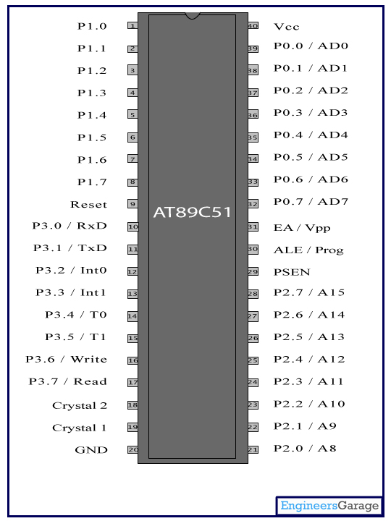**Pin Diagram of AT89C51:**

**Fig no.1**

**Pin Description of AT89C51:**

|  |  |  |  |  |
| --- | --- | --- | --- | --- |
| **Pin No** | **Function** | | | **Name** |
| 1 | 8 bit input/output port (P1) pins | | | P1.0 |
| 2 | P1.1 |
| 3 | P1.2 |
| 4 | P1.3 |
| 5 | P1.4 |
| 6 | P1.5 |
| 7 | P1.6 |
| 8 | P1.7 |
| 9 | Reset pin; Active high | | | Reset |
| 10 | Input (receiver) for serial communication | RxD | 8 bit input/output port (P3) pins | P3.0 |
| 11 | Output (transmitter) for serial communication | TxD | P3.1 |
| 12 | External interrupt 1 | Int0 | P3.2 |
| 13 | External interrupt 2 | Int1 | P3.3 |
| 14 | Timer1 external input | T0 | P3.4 |
| 15 | Timer2 external input | T1 | P3.5 |
| 16 | Write to external data memory | Write | P3.6 |
| 17 | Read from external data memory | Read | P3.7 |
| 18 | Quartz crystal oscillator (up to 24 MHz) | | | Crystal 2 |
| 19 | Crystal 1 |
| 20 | Ground (0V) | | | Ground |
| 21 | 8 bit input/output port (P2) pins  /  High-order address bits when interfacing with external memory | | | P2.0/ A8 |
| 22 | P2.1/ A9 |
| 23 | P2.2/ A10 |
| 24 | P2.3/ A11 |
| 25 | P2.4/ A12 |
| 26 | P2.5/ A13 |
| 27 | P2.6/ A14 |
| 28 | P2.7/ A15 |
| 29 | Program store enable; Read from external program memory | | | PSEN |
| 30 | Address Latch Enable | | | ALE |
| Program pulse input during Flash programming | | | Prog |
| 31 | External Access Enable;  Vcc for internal program executions | | | EA |
| Programming enable voltage; 12V (during Flash programming) | | | Vpp |
| 32 | 8 bit input/output port (P0) pins    Low-order address bits when interfacing with external memory | | | P0.7/ AD7 |
| 33 | P0.6/ AD6 |
| 34 | P0.5/ AD5 |
| 35 | P0.4/ AD4 |
| 36 | P0.3/ AD3 |
| 37 | P0.2/ AD2 |
| 38 | P0.1/ AD1 |
| 39 | P0.0/ AD0 |
| 40 | Supply voltage; 5V (up to 6.6V) | | | Vcc |

* **Power Supply:**

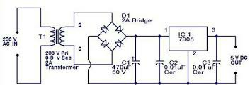

Fig no.2

Power supply is a reference to a source of electrical power. A device or system that supplies electrical or other types of energy to an output load or group of loads is called a power supply unit or PSU. The term is most commonly applied to electrical energy supplies, less often to mechanical ones, & rarely to others. Here in our application we need a 5v DC power supply for all electronics involved in the project. This requires step down transformer, rectifier, voltage regulator, & filter circuit for generation of 5v DC power. Here a brief description of all the components is given as follows:

* **TRANSFORMER:**

**A transformer** is a device that transfers electrical energy from one circuit to another through inductively coupled conductors — the transformer's coils or "windings". single iron-rich core, or around separate but magnetically-coupled cores. A varying current in the first or "primary" winding creates a varying magnetic field in the core (or cores) of the transformer. This varying magnetic field induces a varying electromotive force (EMF) or "voltage" in the "secondary" winding. This effect is called mutual induction. If a load is connected to the secondary circuit, electric charge will flow in the secondary winding of the transformer and transfer energy from the primary circuit to the load connected in the secondary circuit

* **BRIDGE RECTIFIER :**

A bridge rectifier makes use of four diodes in a bridge arrangement to achieve full-wave rectification. This is a widely used configuration, both with individual diodes wired as shown and with single component bridges where the diode bridge is wired internally.

* **REGULATOR IC (78XX):**

It is a three pin IC used as a voltage regulator. It converts unregulated DC current into regulated DC current. Normally we get fixed output by connecting the voltage regulator at the output of the filtered DC (see in above diagram). It can also be used in circuits to get a low DC voltage from a high DC voltage (for example we use 7805 to get 5V from 12V). There are two types of voltage regulators 1. Fixed voltage regulators (78xx, 79xx) 2. Variable voltage regulators (LM317) in fixed voltage regulators there is another classification 1. +ve voltage regulators 2. -ve voltage regulators Positive voltage reg$ulators:

T$his includes 78xx voltage regulators. The most commonly used ones are 7805 and 7812. 7805 gives fixed 5V DC if input voltage is in (7.5V,20V).



**Fig no.3**

* **The Capaci$tor Filter:**

The simple capaci$tor filter is the most basic type of power supply filter. The application of the simple capacitor filter is very limited. It is sometimes used on extremely high-voltage, low-current power supplies for cathode-ray and similar electron tubes, which require very little load current from the supply. The capacitor filter is also used$ where the power-supply ripple frequency is not critical; this frequency can b$e relatively high. The capacitor (C1) shown in figure 4-15 is a simple filter connected across the output of the rectifier in parallel with the load.



**Fig no.4**

**3.2 Block Diagram of monitoring system:**

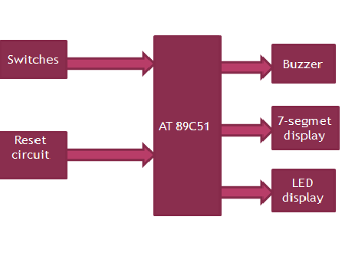

**Fig no.5**

**Reset Circuit:**

**It is an active high output pin. It is used to reset the the microcontroller. Whwn this reset switch is pressed,all ports will be at ‘0’ state.**

**AT89C51:**

**AT89C51 is an 8-bit microcontroller that belongs to Atmel’s 8051 family. ATMEL 89C51 has 4KB of Flash programmable and erasable read only memory (PEROM) and 128 bytes of RAM. It can be erased and program to a maximum of 1000 times. In 40 pin AT89C51, there are four ports designated as P0, P1 ,P2,P3.**

**Buzzer:**

**The buzzer or beeper is an audio signaling device. A piezoelectric element may be driven by an oscillating electronic circuit or other audio signal source, driven with a piezoelectric audio amplifier. Sounds commonly used to indicate that a button has been pressed are click, a ring or a beep.**

**7-segment display:**

**It is a form of electronic device for displaying decimal numerals that is an alternative to mere complex dot matrix displays.**

**3.3 Circuit Diagram of Monitoring System:**

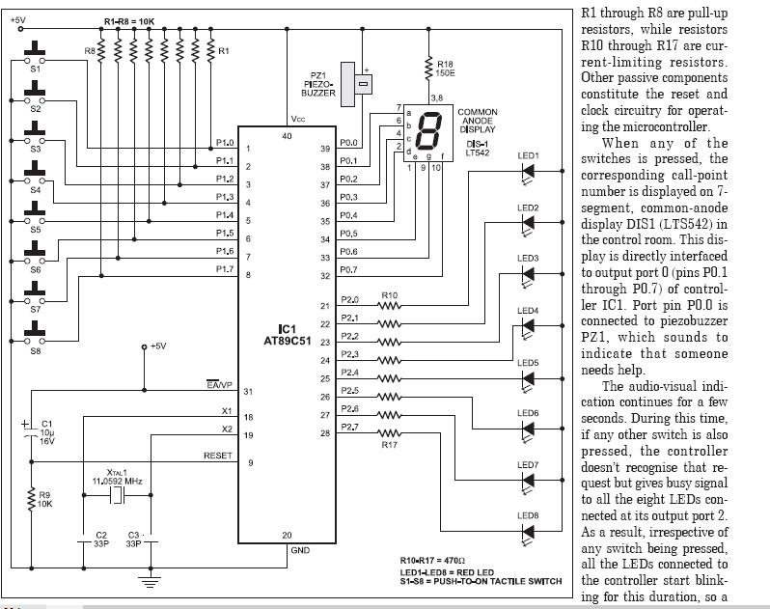

**Fig no.6**

**When any of the switches is pressed the corresponding call-point number is displayed on 7-segment,common-anode display DISI(LTS542) in the control room. This display is directly interfaced to output port 0 (pins p0.1 through p0.7) of controller IC1 port pin p0.0 is connected to peizo-buzzer PZ1 which sounds to indicate that someone needs help.**

**The audio-visual indication continues for a few seconds. During this time if any other switch is also pressed, the controller doesn’t recognize that request but gives busy signal to all the eight LED’s connected at it’s output port 2.As a result irrespective of the call point. The system also provides feedback to the caller(in the form of busy signal)**

**3.4 Software Description:**

**3.4.1 PCB layouts:**

**Basic circuit using 89C51 microcontroller**

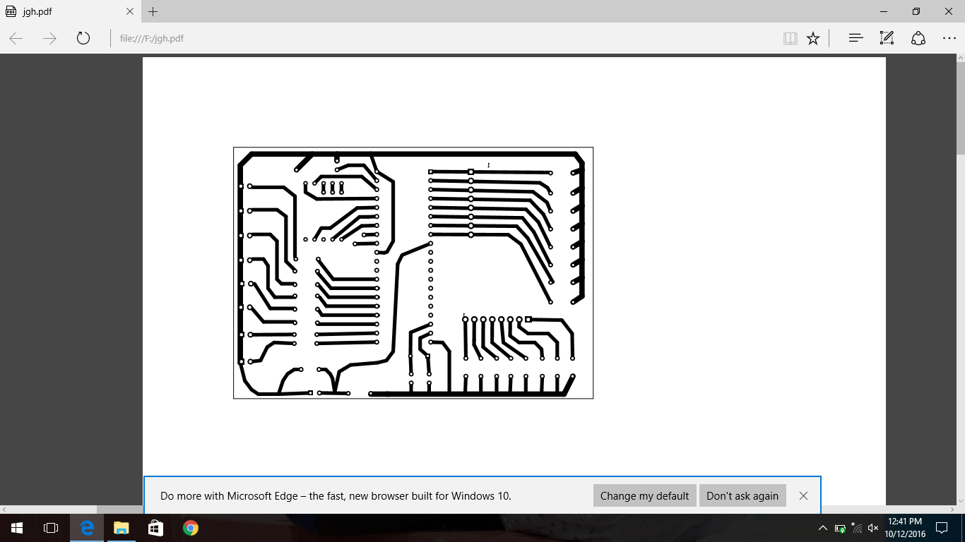

**Fig no.7**

The **Project Windows** area is that part of the screen in which, by default, the Project Window, Functions Window, Books Window, and Registers Window displayed.Within the **Editor Windows** area, you are able to change the source code, view performance and analysis information, and check the disassembly code.

The **Output Windows** area provides information related to debugging, memory, symbols, call stack, local variables, commands, browse information, and find in files results. If, for any reason, you do not see a particular window and have tried displaying/hiding it several times, please invoke the default layout of μ -Vision through the **Window – Reset Current Layout** Menu**.**

**Keil µ-VISION**3:

The μ Vision IDE is, for most developers, the easiest way to create embedded system programs. This chapter describes commonly used μ Vision features and explains how to use them. A Context Menu, invoked through the right mouse button, is provided for most objects. You can use keyboard shortcuts and define your own shortcuts. You can use the abundant features of a modern editor. Menu items and Toolbar buttons are grayed out when not available in the Current context.

**3.4.2 Program:**

ORG 00H

AJMP START

ORG 03H

RETI

ORG 0BH

RETI

ORG 13H

RETI

ORG 1BH

RETI

ORG 23H

RETI

ORG 25H

DELAYMS:

MOV R7,#00H

LOOPA:

INC R7

MOV A,R7

CJNE A,#0FFH,LOOPA

RET

DELAYHS:

MOV R6,#00H

MOV R5,#008H

LOOPB:

INC R6

ACALL DELAYMS

MOV A,R6

JNZ LOOPB

MOV A,0A0H

CPL A

MOV 0A0H,A

MOV A,#00H

DEC R5

MOV A,R5

JNZ LOOPB

RET

START:

MOV 61H,#00H

MOV 62H,#0B0H

MOV 63H,#04H

MOV 64H,#24H

MOV 65H,#32H

MOV 66H,#60H

MOV 67H,#48H

MOV 68H,#0F2H

LOOP:

MOV A,90H

CJNE A,#0FFH,L1

AJMP LOOP

L1:

MOV R4,#00H

L2:

SETB C

RLC A

INC R4

JC L2

MOV A,R4

ADD A,#60H

MOV R0,A

MOV A,@R0

MOV 80H,A

MOV 0A0H,#00H

ACALL DELAYHS

MOV 80H,#0FFH

MOV 0A0H,#0FFH

AJMP LOOP

END

**Chapter no.4**

**Working of Monitoring System**

**In Monitoring System two main circuits are used.**

**1.Basic circuit using microcontroller**

**2.Display section using 7-segment display interface**

**In this Microcontroller only three ports are used.**

**Port 0 acts as an output port**

**Port 1 acts as an input port**

**Port 2 acts as an output port**

**Here’s simple economical room monitoring system that provides audio-visual identification of R1 to R8 are pull-up resistor, while resistor R10 to R17are current-limiting resistors. Other passive components constitute the reset and clock circuitry for operating the microcontroller.**

**When any of the switches is pressed the corresponding call-point number is displayed on 7-segment,common-anode display DISI(LTS542) in the control room. This display is directly interfaced to output port 0 (pins p0.1 through p0.7) of controller IC1 port pin p0.0 is connected to peizo-buzzer PZ1 which sounds to indicate that someone needs help.**

**The audio-visual indication continues for a few seconds. During this time if any other switch is also pressed, the controller doesn’t recognize that request but gives busy signal to all the eight LED’s connected at it’s output port 2.As a result irrespective of the call point. The system also provides feedback to the caller(in the form of busy signal) Using minimal hardware and software, it’s clean and easy way to communicate.**

**Flash-based microcontroller IC AT9C51 is at the heart of the monitoring circuit. Port 0,1, and 2 of IC are used as output ,input and output ports respectively. Switches S1 through S8 are interfaced as inputs to controller IC via port 1(p1.0 through p1.7). These switches along with the respective LED’s are to be installed in eight different rooms, while the remaining circuit is to be place in the control room. Resistors caller gets to know that the he has to wait for some time. When the LED’s stops blinking he can press the switch for help. The LED again blinks to indicate that the request is being processed.**

* **Features of Monitoring System:**

**1. High compatibility**

**2. Time saving$**

**3. Simple and easy to understand$**

**Chapter no. 5**

**Future Scope**

In future this project used in other applications like hospitals, colleges by adding some additional component to this project. Hence this project is cost effective it saves time, money and efforts of a person.

$

**Chapter no. 6**

**Summary and Conclusion**

Program the Microcontroller with the mp.HEX file using AT89C51 programmer. After successfully programming the code, take the microcontroller out from the programmer and connect it to its IC base on the PCB of the circuit. After assembling and soldering all other components, connect a 5v dc external power supply. Now if you pressed any switch, the corresponding call point number should display for a few seconds. At the same time, LEDs at all the call point should blink and the buzzer in the control room should sound for this duration. Integrating features of all the hardware components used have been developed in it presence of every module has been reasoned out and placed carefully, thus contributing to the best working of the unit. Using highly advanced ICs with the help of growing technology the project has been successfully implemented. Thus project has been successfully designed and tested.

**Chapter no. 7**

**Reference**

1. [**www.google.com**](http://www.google.com)
2. [**www.electronicsforu.com**](http://www.electronicsforu.com)
3. [**www.wikipedia.com**](http://www.wikipedia.com)
4. **Ramesh Chopra for EFY Enterprises pvt. Ltd**

**D-87/1 Okhla industrial area phase 1, New Delhi, 110 020**